# Visual Analysis on the Covid-19 Pandemic

# Recovery of Hong Kong

Zhou Xingjian 3036195148

1. Assigned Tasks

In general, our project focused on three aspects, which are vacancy, transportation, and retail sales, to evaluate whether Hong Kong has recovered from the COVID-19 or not. I was assigned to help my teammates analysis the data critically, which lead to an overall conclusion, and develop a webpage for a better navigation effect compared to the Tableau dashboard navigation.

2. Details of tasks

* For vacancy part:

I introduce the new take-up figures to evaluate the market of office buildings more sufficiently. The take-up figures are arrived at by adding the completions in that year to the vacancy figures at the beginning of the year, then subtracting the year's demolition and the year-end vacancy figures.

Figure 1. vacancy rate, ref: Yi Heng’s work.

Figure 2. take-up values for all buildings, which describe vacancy in another perspective.

We can see it clearly that, in figure 1, the vacancy rates are increasing for office buildings graded in “A” and “B”, while the rate for buildings graded “C” is decreasing. However, it is not very sufficient for us to evaluate the situation of office buildings in Hong Kong. The take-up values in figure 2 show some additional information, especially when we choose to check values in grade “A” and “C”.

Figure 3. take-up values for buildings graded in “A”.

Figure 4. take-up values for buildings graded in “C”.

Combining with figure 1, figure 3 and figure 4, I noticed that it is abnormal for grade “A” buildings in that its take-up value is positive, while its vacancy rate continues to increase. We can infer that people may not afford to pay the cost for grade “A” buildings and start to replace with grade “C” buildings.

* For conclusions:

Figure 5. the inter transportation in Hong Kong, ref: Wang Yilin’s work.

Figure 6. total retail sales by month and data in 2019 is set as base line, ref: Zhong Hao’s work.

I picked two figures to demonstrate the most general conclusion we draw from our works, that is that Hong Kong has started to recover from the COVID-19, but still not reached the base line before the plague yet. We can see that in figure 5, due to the traffic control policy, the inter transportation for Hong Kong nearly falls to one in a thousand compared to data of the pre-pandemic period. Even we counted the data after COVID-19, the picture still shows a weak view compared to the pre-pandemic data. But it is a good signal that the data recovered in a rapid way, which may infer that the economy of Hong Kong has gained its motivation. And for figure 6, we set the total retail sales by month in 2019 as base line, and surprisingly found that even the data are below in the most of time during COVID-19, the data after August in 2023 are all above the base line. All these clues lead to our conclusion.

* For webpage:

We use web as our project UI framework in that tableau dashboard navigation is hard to use and has difficulties in displaying our project’s structure. I developed a webpage equipped with clear navigations to contain all our works. And the simple UI in figure 7 shows the structure of our project. Compared to Figure 8, it displays a clearer contained sub-context. A screenshot of a computer

Figure 7. webpages presentation.

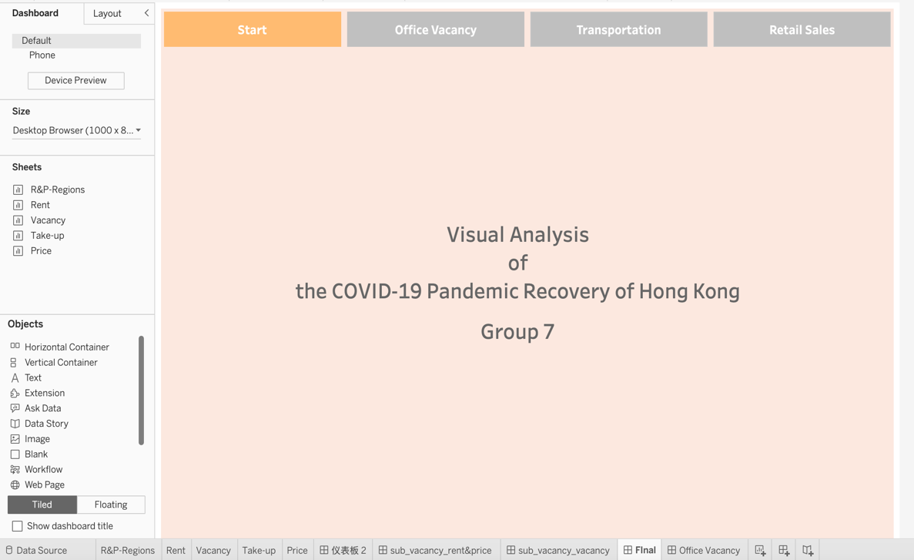

Figure 8. original tableau navigation.